Omega Exploration Map - Signals

Please fill out the following sections of your map for your project. Many of you will learn skills or concepts that are beyond the Intro to ECSE concept list. Please provide references, links to website, pictures or screenshots of how you explored in your project!

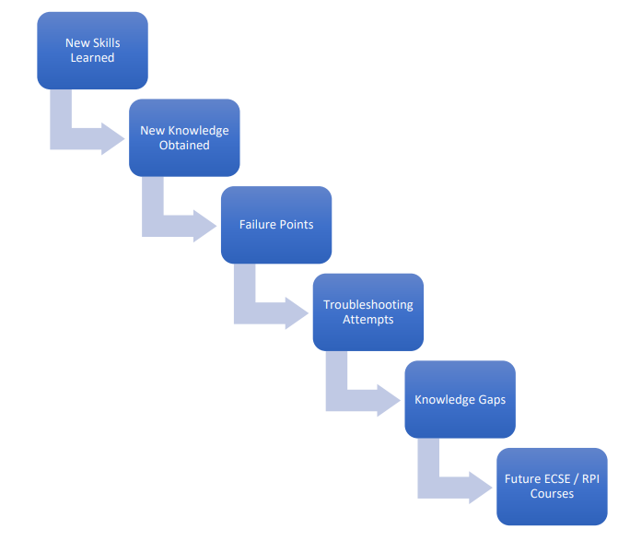
Contents
EMPAC Media Technologies 1
How is this Related to ECSE? 1
Sound Manipulation: Electrical vs. Mechanical 2
Failures, Challenges, and Lessons Learned 2
Knowledge Gaps 3
Future ECSE/RPI Courses 3

EMPAC Media Technologies
Below is a list of ECSE topics. On your tour you will see real-world examples of how most (if not all) of these topics are applied to enable what’s possible at EMPAC. For at least three of the following topics, list an example of how that area of ECSE is used at EMPAC or where you saw it on your tour. Which one do you find most interesting?
- Signal Transmission (getting a signal from one place to another)
- Audio Signal Processing
- Video Signal Processing
- Light-Emitting Devices (where? what kind? what are they used for?)
- Networking (managing all of the data at EMPAC)

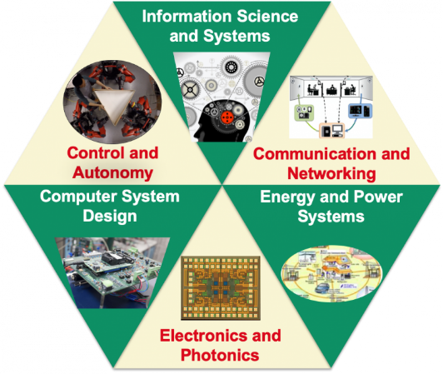
How is this Related to ECSE?
For the three topics for which you identified examples at EMPAC above, determine which main area of ECSE (shown to the right) each of them belongs in.

Sound Manipulation: Electrical vs. Mechanical
In electrical engineering, we manipulate sound by converting it into an electrical signal (microphone), then sending it through a circuit to modify it, and finally outputting it (speaker). There are also ways to design the physical space the sound is already in to modify it mechanically. What features in the different spaces in EMPAC are designed so that they modify the sounds in those spaces mechanically?

Failures, Challenges, and Lessons Learned
In terms of all of the technology that was designed for use in EMPAC, was there anything that needed to be changed, corrected, updated, or redesigned because the design did not work as initially intended? What was learned from this “failure”?

Knowledge Gaps
What things on your EMPAC tour did you not understand?

Future ECSE/RPI Courses
Which course(s) at RPI do you think would help you fill in the knowledge gaps that you listed above? And why?

Exploration Map Grading
Exploration Map Standards
- Exploration Completed

